DEALS TO SANTA MONICA

Santa Monica is a beautiful beachfront city in the Los Angeles area with a fantastic pier, world-class restaurants and exclusive shopping. From its fabulous beaches and nightlife, to its unique museums and shopping, there are plenty of fun things to do in Santa Monica. Book a trip to Santa Monica via Los Angeles International Airport on Virgin America. Live it up at 35,000 feet with WiFi, on-demand entertainment, and more on every flight.

(MARKET IMAGE HERE)

Find Deals From These Cities

INSERT FARE GRID FROM / TO Version (if available!)

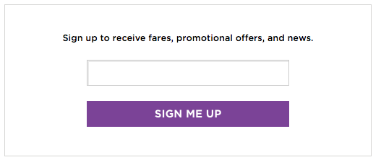   
Top Things To Do in Santa Monica

If you’re not sure what you should try first, check out some of the great attractions below - they’re sure to be a hit!

* Visit the Santa Monica Pier. Home to the Pacific Park amusement park, the Santa Monica Pier Aquarium, the New York Trapeze School, and more!
* Bike “The Strand”. This 22-mile paved beach path runs from just north of Santa Monica to Torrance Beach in the south. Rent a bike and enjoy the beautiful ride, taking in the various sights along the way.
* See a great play. The Santa Monica Playhouse may be a small theatre, but it has earned a fantastic reputation since it first opened in 1960.
* Don’t forget to simply spend time on the soft sand of Santa Monica’s beaches! If the sun and surf aren’t for you, check out the Annenberg Beach House. This community center features a historic home with guided tours along with a fitness center, pool and art gallery.

Travel Tips and Resources

[Must-Dos in Santa Monica](http://www.tripadvisor.com/Attractions-g33052-Activities-Santa_Monica_California.html)

[Santa Monica Hotels](http://www.tripadvisor.com/Hotels-g33052-Santa_Monica_California-Hotels.html)

[Santa Monica Restaurants](http://www.laweekly.com/restaurants/10-best-restaurants-in-santa-monica-4177802)

[Santa Monica Shopping Guidehttp://www.santamonica.com/shopping](http://www.santamonica.com/shopping)

[Santa Monica Nightlife and Entertainmenthttp://www.santamonica.com/restaurants/santa-monica-nightlife-scene](http://www.santamonica.com/restaurants/santa-monica-nightlife-scene)

[Santa Monica Travel Tips](http://www.travelandleisure.com/travel-guide/santa-monica)

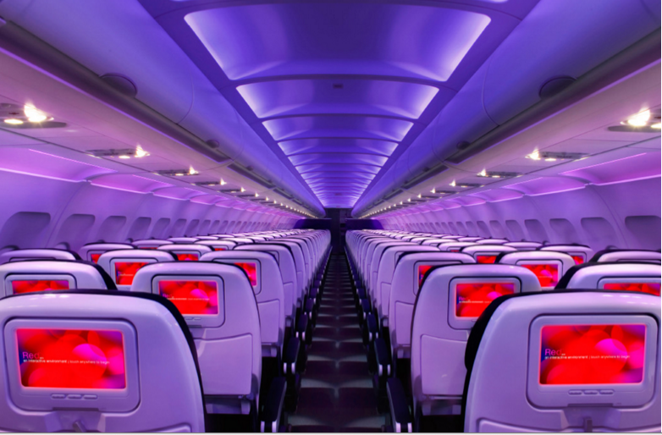

Main Cabin Main Cabin Select First Class

(add links to Cabin Class Pages)

Ready. Set. Fly.

Book your Mood-lit Ride to Santa Monica.

If you’re researching flights to Santa Monica, you’ll find that Los Angeles International is just a few minutes away from Santa Monica. Book your flight to Los Angeles with Virgin America and then take the quick drive from LAX to Santa Monica. After experiencing the in-flight amenities we offer, such as our mood-lit cabins, specially designed leather seats, and on-demand WiFi (to name a few), you’ll be amazed that flying can be so comfortable.

Take a Virtual Tour

Add Terms & Conditions